The Iron ‐ Iron Carbide (Fe‐Fe₃C) Phase Diagram
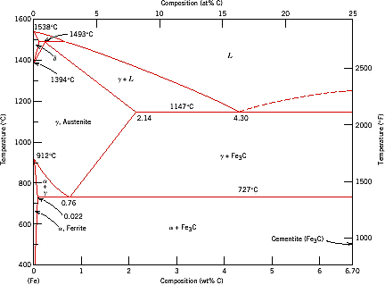

Reactions
Peritectic L + δ = γ
at T=1493oC and 0.18wt%C

Eutectic L = γ + Fe₃C
at T=1147oC and 4.3wt%C

Phases Present

L

Eutectoid γ = α + Fe C
γ austenite Fcc structure Non‐magnetic ductile
δ ferrite delta Bcc structure Paramagnetic
3
at T=727oC and 0.77wt%C

Max. solubility of C in ferrite=0.022% in austenite=2.11%
Fe₃C cementite Orthorhombic Hard, brittle
α ferrite Bcc structure Ferromagnetic Fairly ductile

Phases in Fe–Fe₃C Phase Diagram
- α‐ferrite ‐ solid solution of C in BCC Fe
  - Stable form of iron at room temperature.
  - Transforms to FCC g‐austenite at 912 °C
- γ‐austenite ‐ solid solution of C in FCC Fe
  - Transforms to BCC δ‐ferrite at 1395 °C
  - Is not stable below the eutectic temperature (727 ° C) unless cooled rapidly.
- δ‐ferrite solid solution of C in BCC Fe
  - It is stable only at T, >1394 °C. It melts at 1538 °C
- Fe₃C (iron carbide or cementite)
  - This intermetallic compound is metastable at room T. It decomposes (very slowly, within several years) into α‐Fe and C (graphite) at 650 ‐ 700 °C
- Fe‐C liquid solution

Comments on Fe–Fe₃C system
C is an interstitial impurity in Fe. It forms a solid solution with α, γ,
δ phases of iron
Maximum solubility in BCC α‐ferrite is 0.022 wt% at 727 °C. BCC: relatively small interstitial positions
Maximum solubility in FCC austenite is 2.14 wt% at 1147 °C ‐ FCC has larger interstitial positions
Mechanical properties: Cementite (Fe₃C is hard and brittle: strengthens steels). Mechanical properties also depend on microstructure: how ferrite and cementite are mixed.
Magnetic properties: α ‐ferrite is magnetic below 768 °C, austenite is non‐magnetic

Classification.
Three types of ferrous alloys:
Iron: < 0.008 wt % C in α‐ferrite at room T Steels: 0.008 ‐ 2.14 wt % C (usually < 1 wt % )
α‐ferrite + Fe₃C at room T
Cast iron: 2.14 ‐ 6.7 wt % (usually < 4.5 wt %)

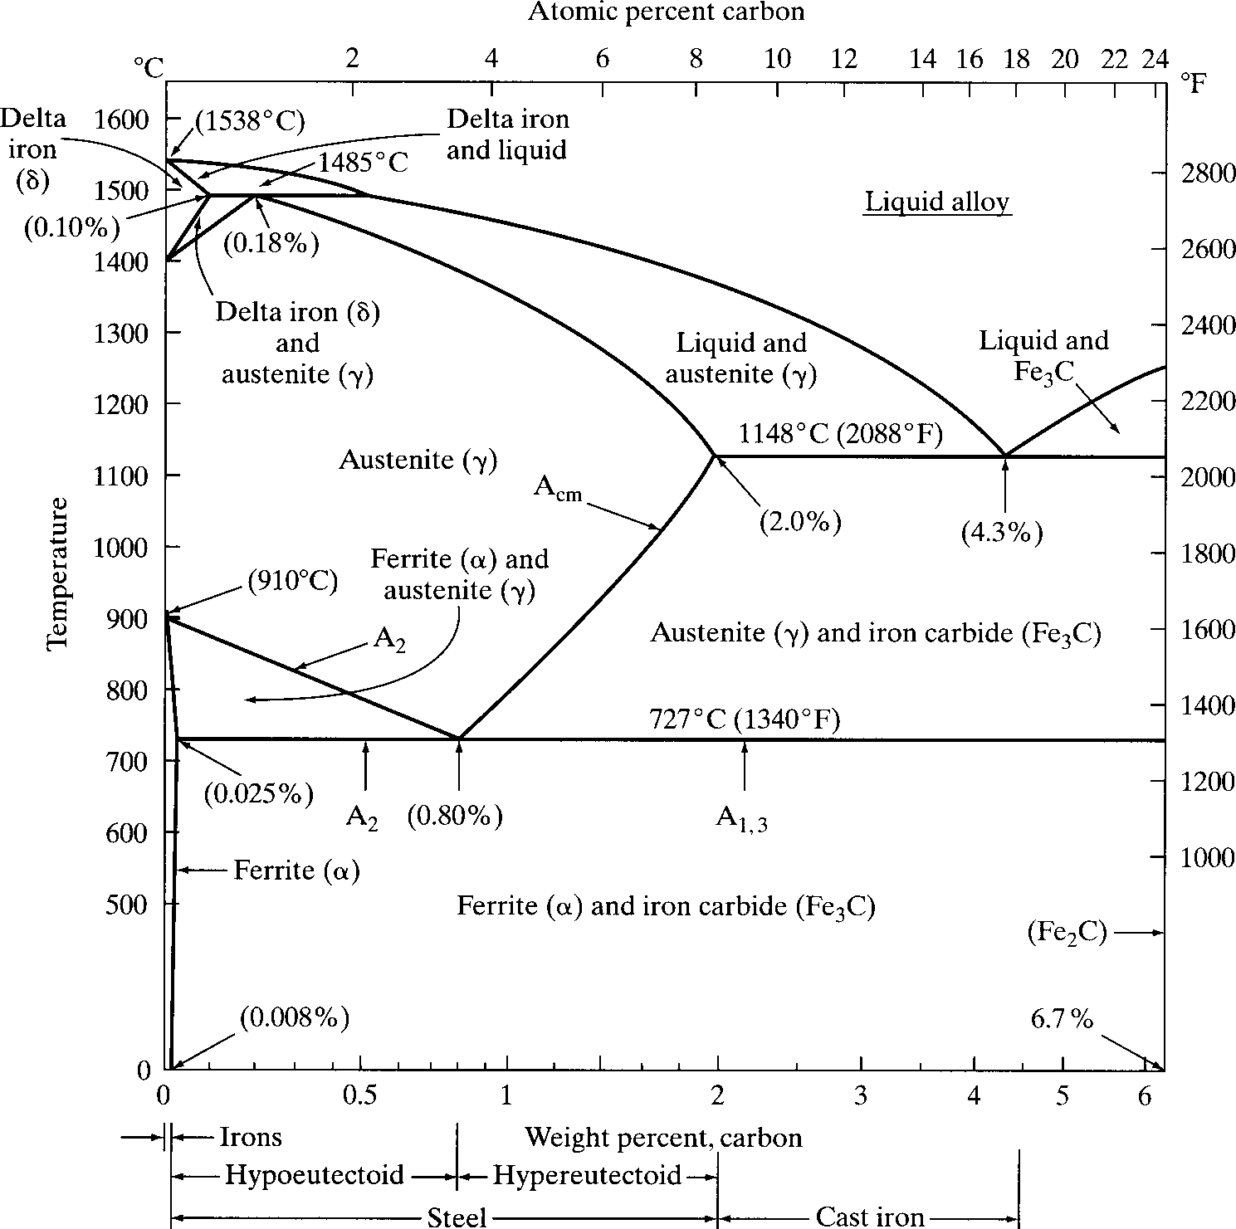

3

1

3

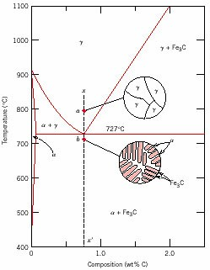
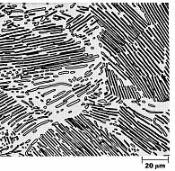
Eutectoid steel

Microstructure of eutectoid steel
Alloy of eutectoid composition (0.76 wt % C) is cooled slowly: forms
pearlite, layered structure of two phases: α‐ferrite and cementite (Fe3C)
Mechanically, pearlite has properties
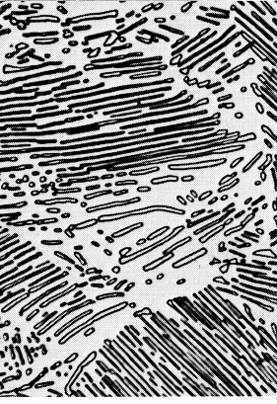
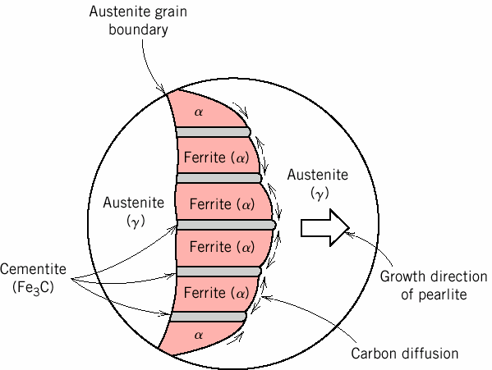
intermediate to soft, ductile ferrite and hard, brittle cementite.

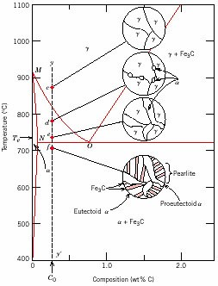
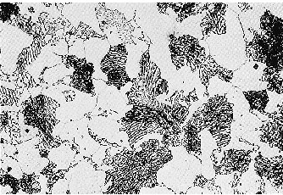
Hypoeutectoid steel

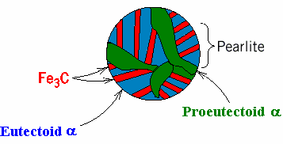
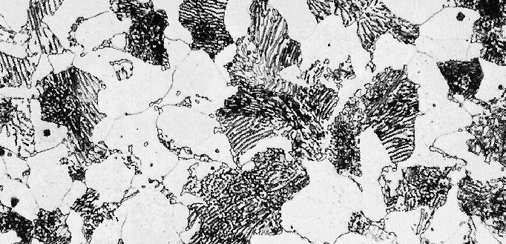
Hypoeutectoid alloys
contain proeutectoid ferrite (formed above the eutectoid temperature) plus the eutectoid perlite that contain eutectoid ferrite and cementite.

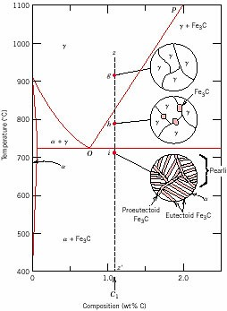

Hypereutectoid steel

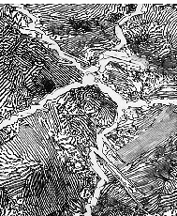

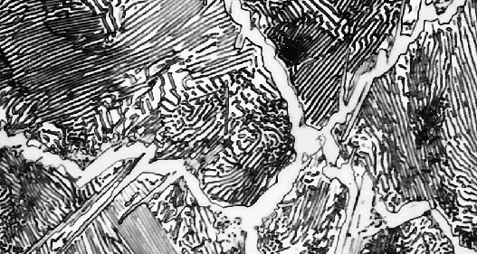
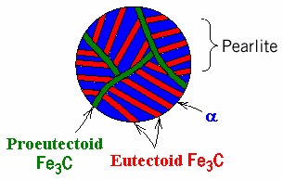
Hypereutectoid alloys contain proeutectoid cementite (formed above the eutectoid temperature) plus perlite that contain eutectoid ferrite and cementite.

